Bisector

Definition
# Source: AI Source: Provided by: [Data Path: Persons Table -> ID Column: 1, Name_En Column: Motasem Essam] -> From: [ChatGPT] on [7/25/2026]
A bisector is a geometric object that divides another geometric object into two equal parts.
The object being divided determines the type of bisector.
The two most important types are:
- Angle Bisector
- Segment Bisector

Purpose
# Source: AI Source: Provided by: [Data Path: Persons Table -> ID Column: 1, Name_En Column: Motasem Essam] -> From: [ChatGPT] on [7/25/2026]
A bisector is used to:
- Divide an angle into two congruent angles.
- Divide a line segment into two congruent segments.
- Locate the center of a segment.
- Construct geometric figures accurately.
- Find important points in triangles and other geometric figures.

Types of Bisectors

1. Angle Bisector
# Source: AI Source: Provided by: [Data Path: Persons Table -> ID Column: 1, Name_En Column: Motasem Essam] -> From: [ChatGPT] on [7/25/2026]
An angle bisector is a ray, line, or segment that divides an angle into two congruent angles.
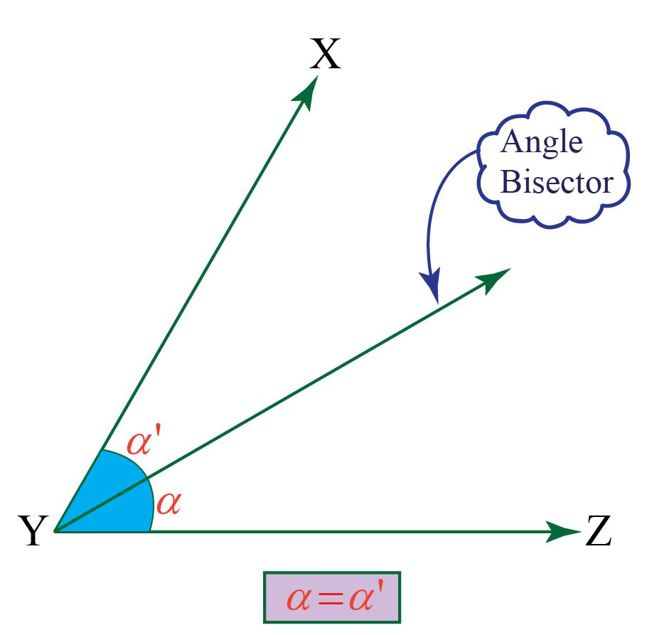
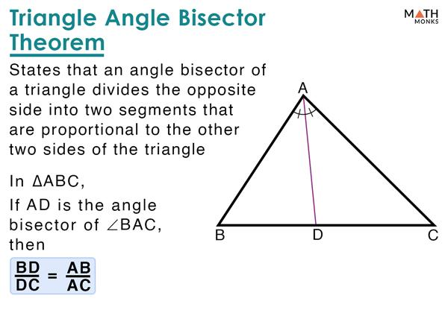
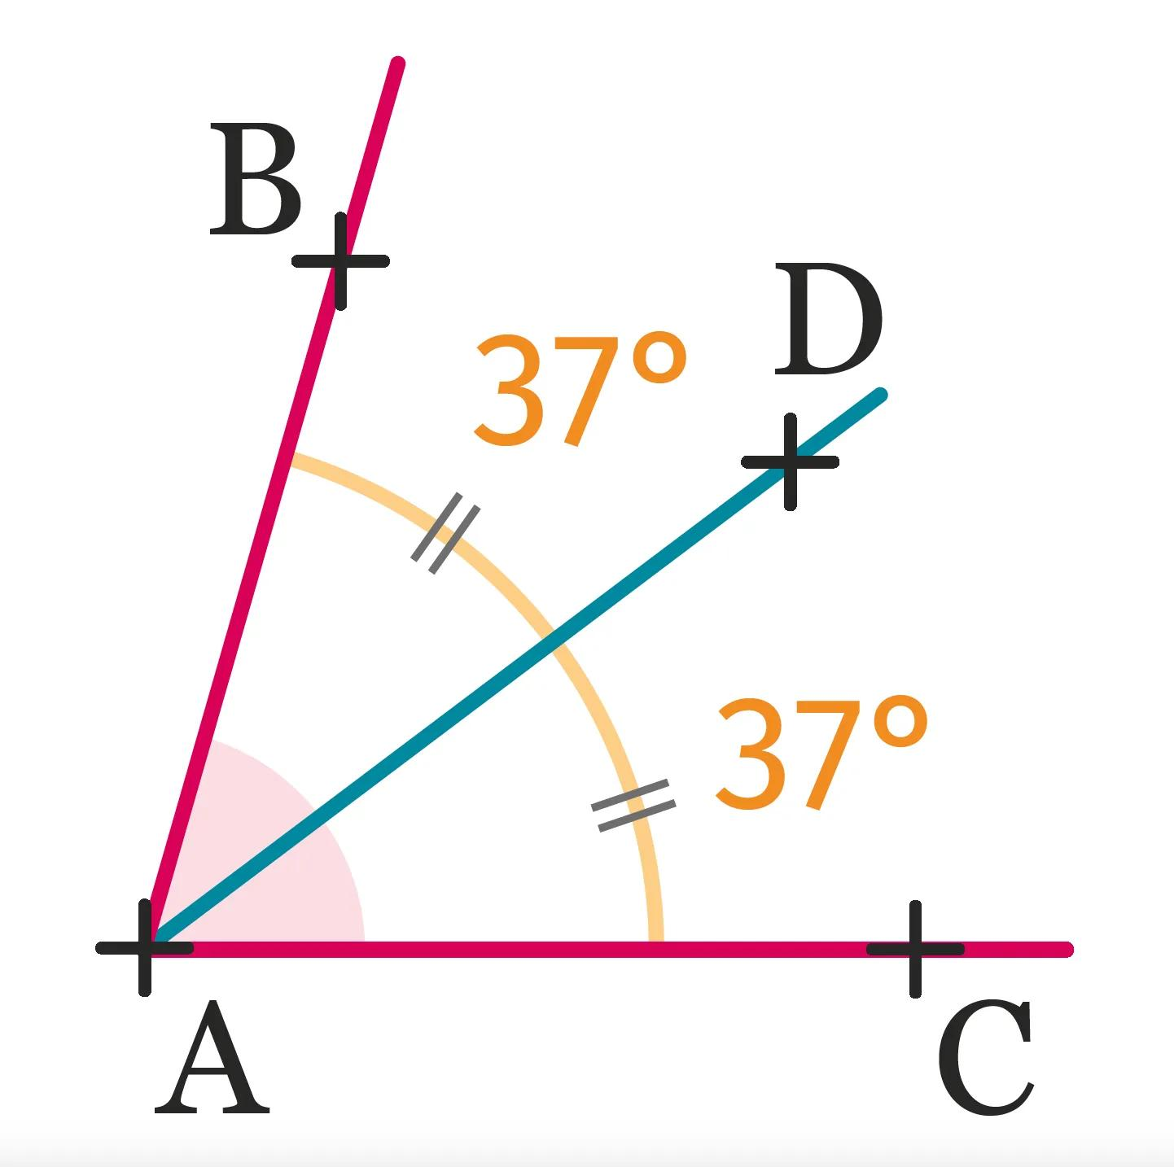
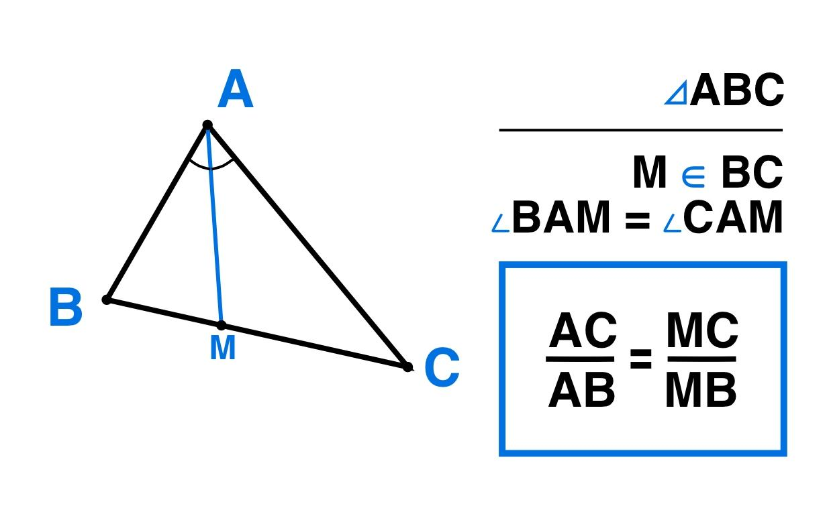
If ray $\vec{BD}$bisects $∠ABC$, then:
$$∠ABD=∠DBC$$
Therefore:
$$\boxed{∠ABC=2∠ABD}$$
Example
If:
$$∠ABC={80}^{∘}$$
and $BD$is its angle bisector:
$$∠ABD=∠DBC=\frac{{80}^{∘}}{2} \\ \boxed{{40}^{∘}}$$

2. Segment Bisector
# Source: AI Source: Provided by: [Data Path: Persons Table -> ID Column: 1, Name_En Column: Motasem Essam] -> From: [ChatGPT] on [7/25/2026]
A segment bisector is a line, ray, or segment that divides a line segment into two congruent segments.
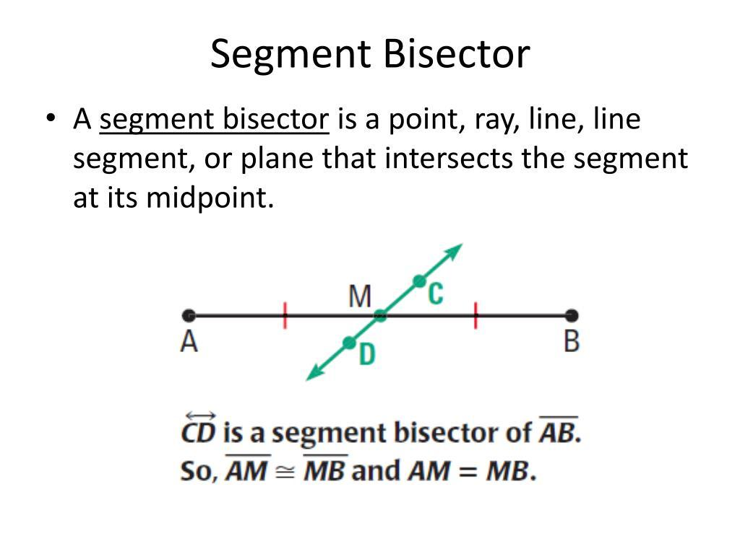
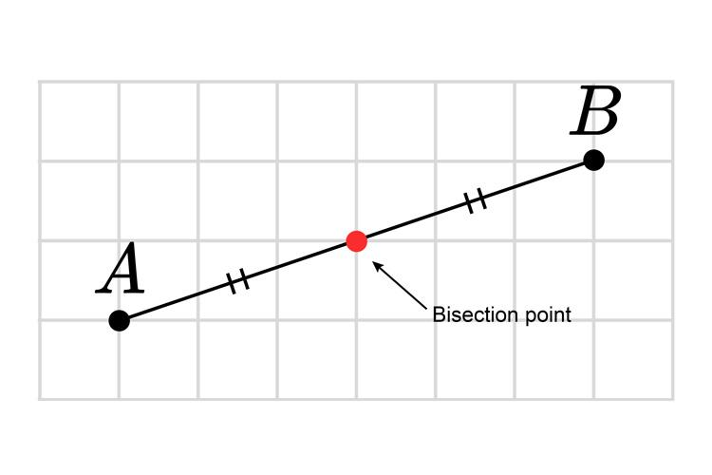
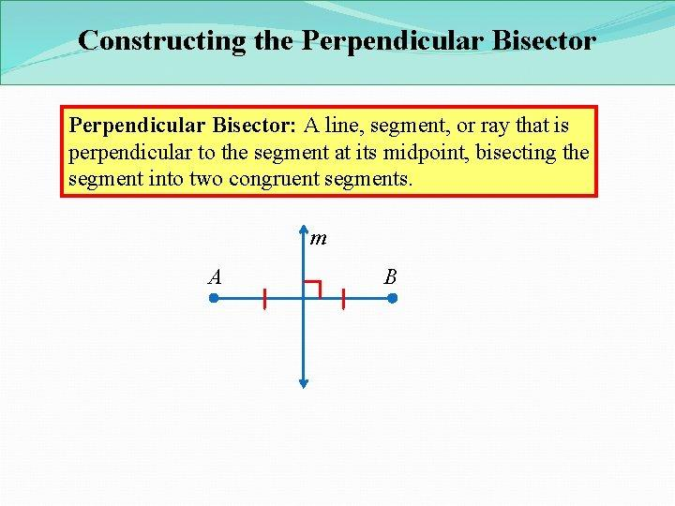
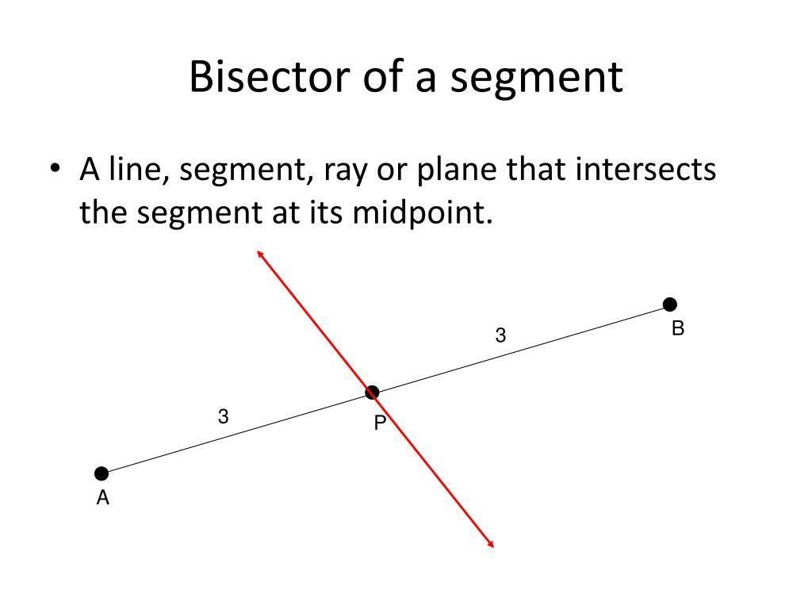
If $M$bisects $\overset{‾}{AB}$, then:
$$AM=MB$$
Therefore, $M$is the midpoint of $\overset{‾}{AB}$.

Bisector vs. Midpoint
# Source: AI Source: Provided by: [Data Path: Persons Table -> ID Column: 1, Name_En Column: Motasem Essam] -> From: [ChatGPT] on [7/25/2026]
These concepts are closely related but are not the same thing.
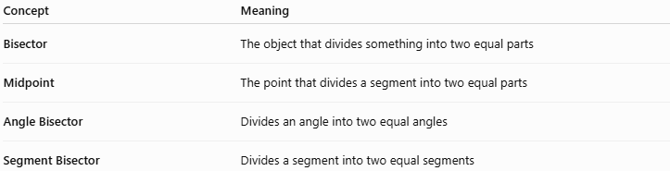
Concept | Meaning
Bisector | The object that divides something into two equal parts
Midpoint | The point that divides a segment into two equal parts
Angle Bisector | Divides an angle into two equal angles
Segment Bisector | Divides a segment into two equal segments
For example:
$$A∙⟶M⟶∙B$$
If:
$$AM=MB$$
then $M$is the midpoint.
A line passing through $M$and dividing $\overset{‾}{AB}$into two equal parts is a segment bisector.

Perpendicular Bisector
# Source: AI Source: Provided by: [Data Path: Persons Table -> ID Column: 1, Name_En Column: Motasem Essam] -> From: [ChatGPT] on [7/25/2026]
A perpendicular bisector is a special type of segment bisector that:
- passes through the midpoint of a segment, and
- is perpendicular to the segment.
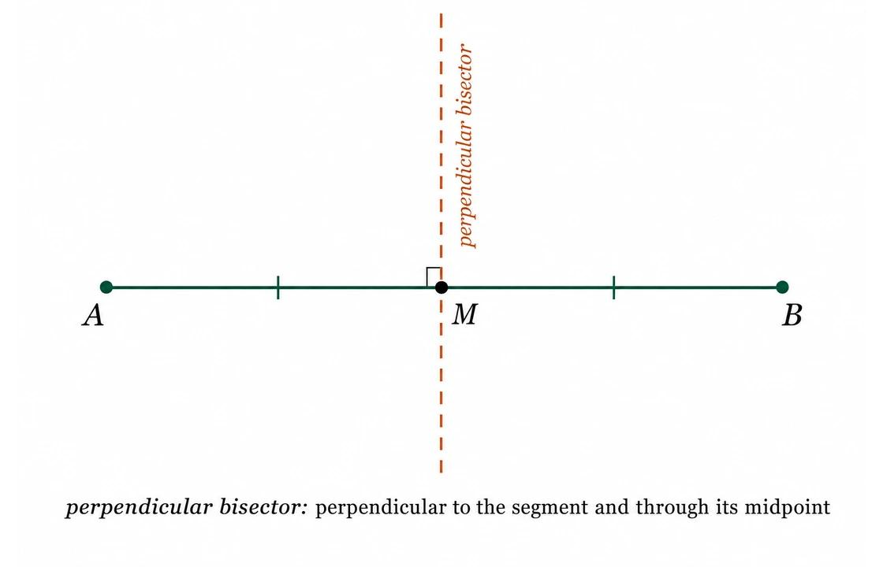
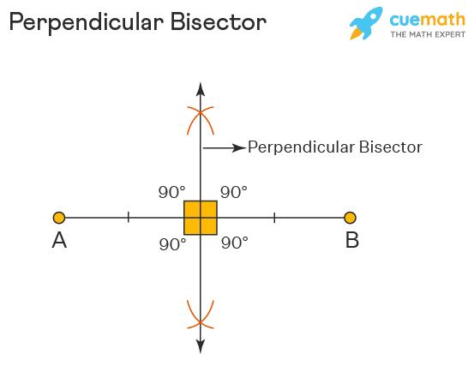
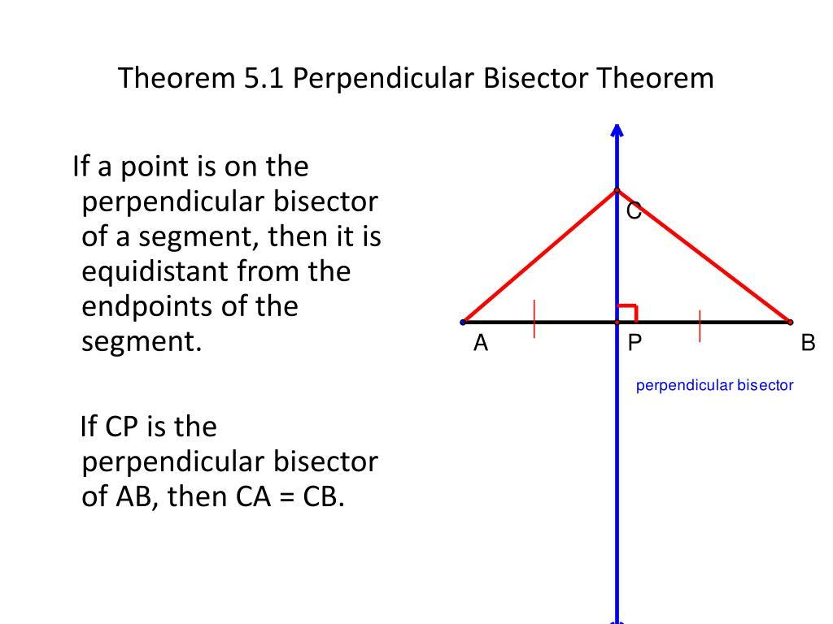
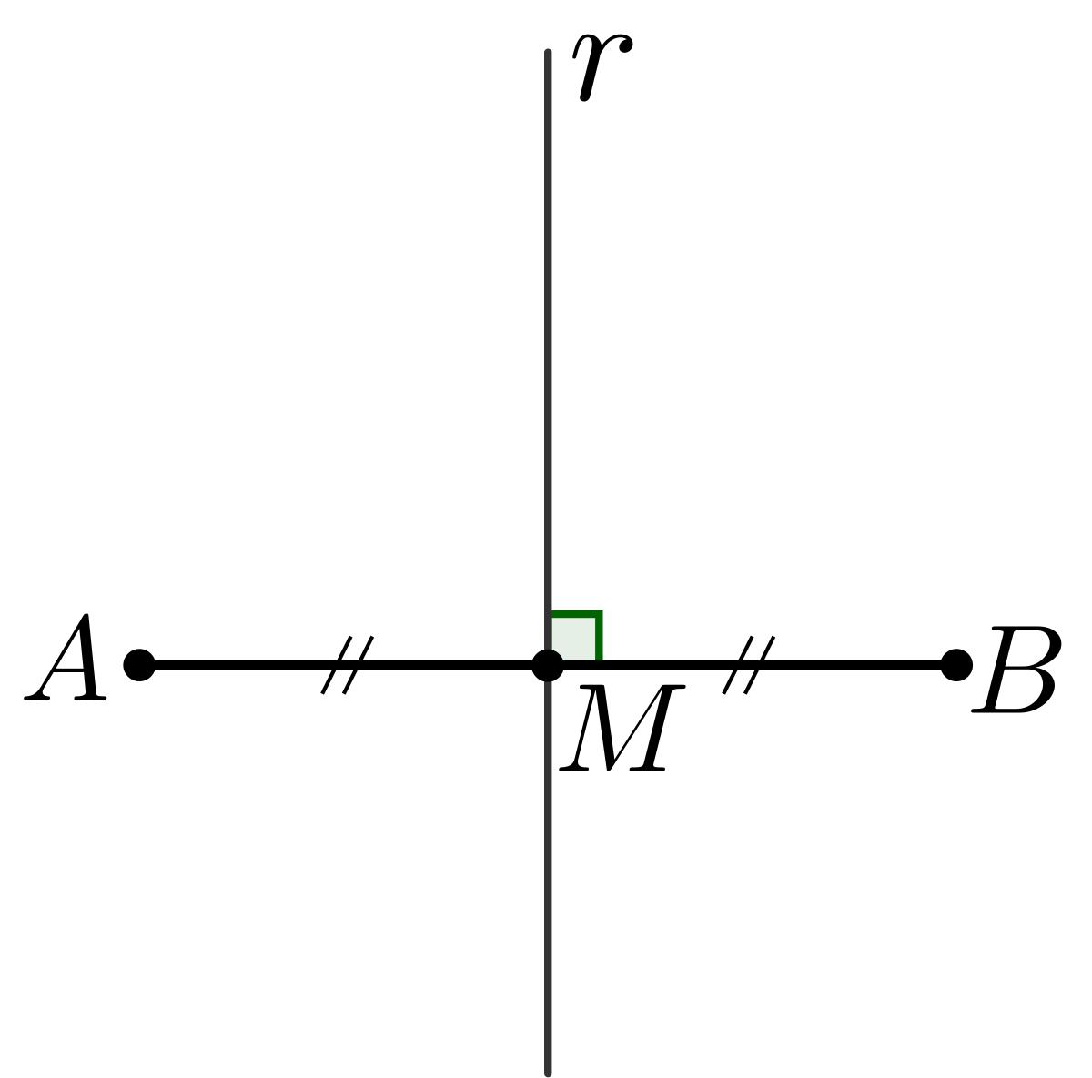
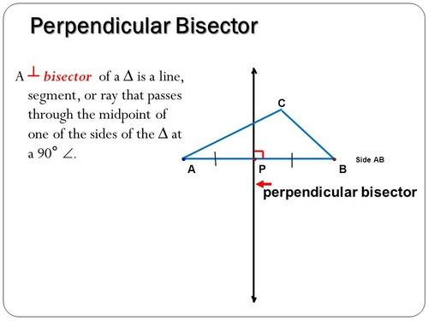
If line $l$bisects $\overset{‾}{AB}$at $M$, and:
$$l⊥\overset{‾}{AB}$$
then:
$$AM=MB$$
and:
$$∠AMl={90}^{∘}$$
Thus, $l$is the perpendicular bisector of $\overset{‾}{AB}$.

Angle Bisector vs. Perpendicular Bisector
# Source: AI Source: Provided by: [Data Path: Persons Table -> ID Column: 1, Name_En Column: Motasem Essam] -> From: [ChatGPT] on [7/25/2026]
These should not be confused.
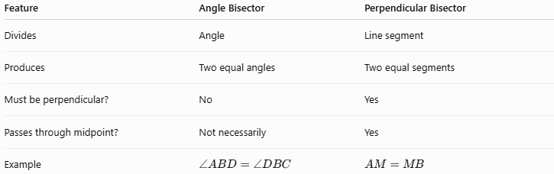
Feature | Angle Bisector | Perpendicular Bisector
Divides | Angle | Line segment
Produces | Two equal angles | Two equal segments
Must be perpendicular? | No | Yes
Passes through midpoint? | Not necessarily | Yes
Example | $$∠ABD=∠DBC$$ | $$AM=MB$$

Bisectors in a Triangle
# Source: AI Source: Provided by: [Data Path: Persons Table -> ID Column: 1, Name_En Column: Motasem Essam] -> From: [ChatGPT] on [7/25/2026]
Bisectors are particularly important in triangles.

Angle Bisectors
# Source: AI Source: Provided by: [Data Path: Persons Table -> ID Column: 1, Name_En Column: Motasem Essam] -> From: [ChatGPT] on [7/25/2026]
An angle bisector divides a triangle's angle into two equal angles.
For example:
$$∠BAD=∠DAC$$
if $AD$is the angle bisector of $∠A$.
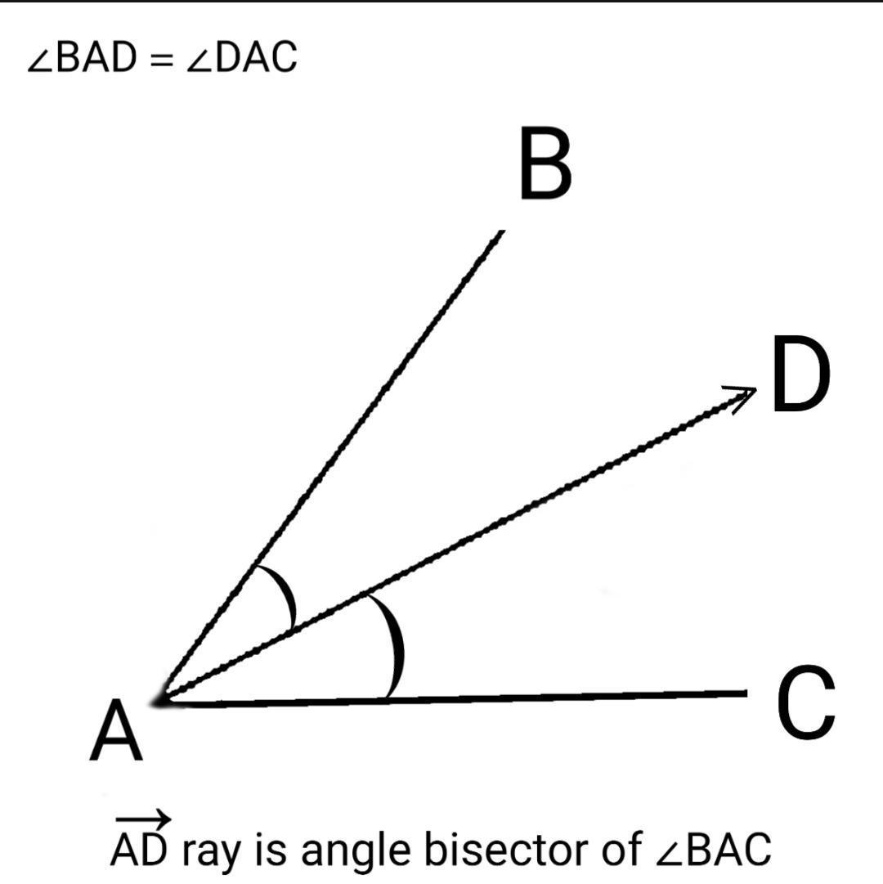
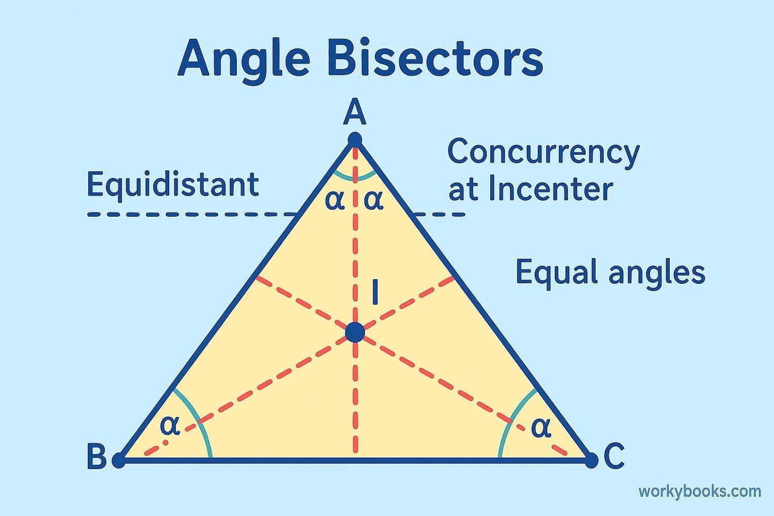
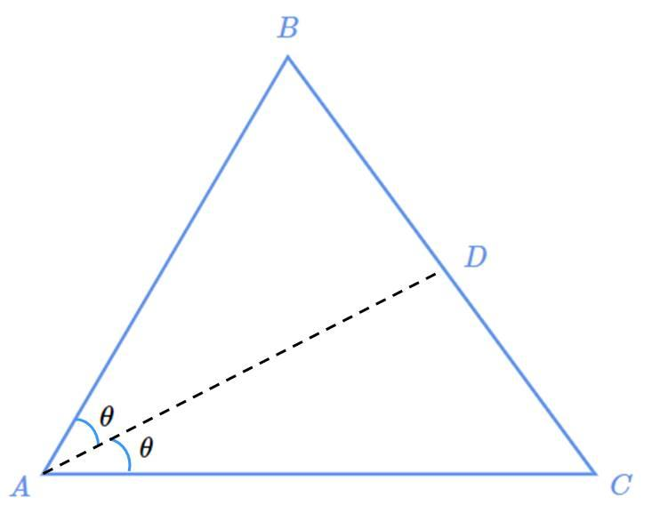
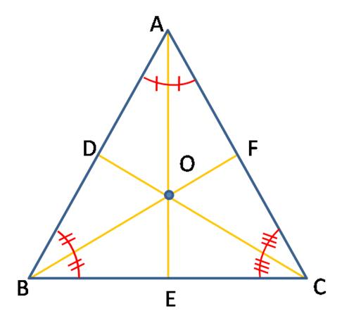
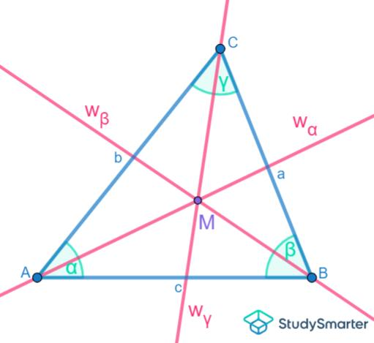
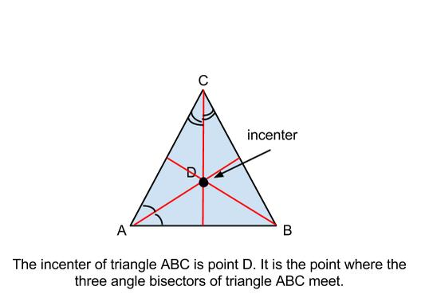
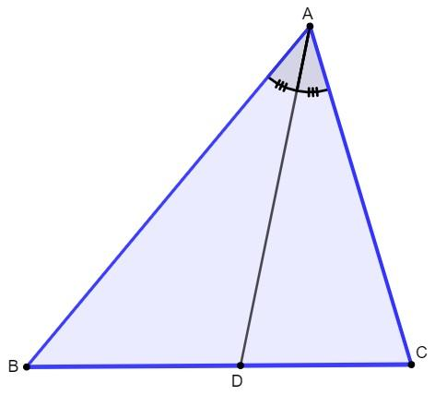
The three internal angle bisectors of a triangle meet at the incenter.

Perpendicular Bisectors
# Source: AI Source: Provided by: [Data Path: Persons Table -> ID Column: 1, Name_En Column: Motasem Essam] -> From: [ChatGPT] on [7/25/2026]
The perpendicular bisectors of the three sides of a triangle meet at the circumcenter.
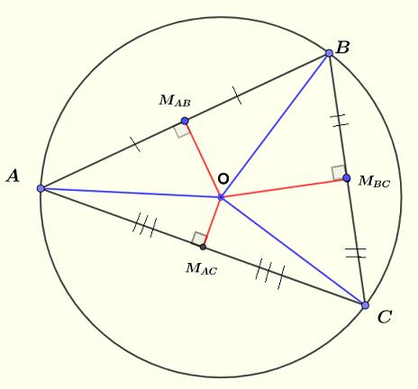
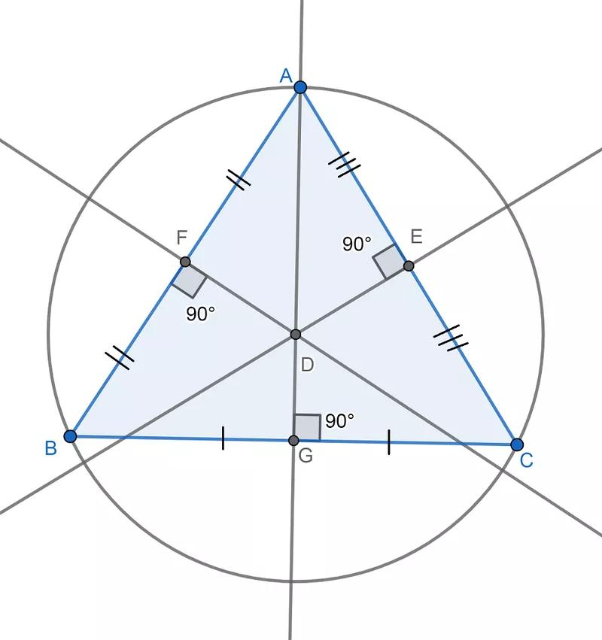
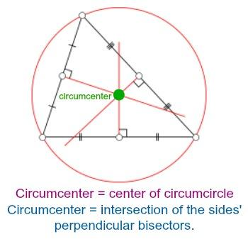
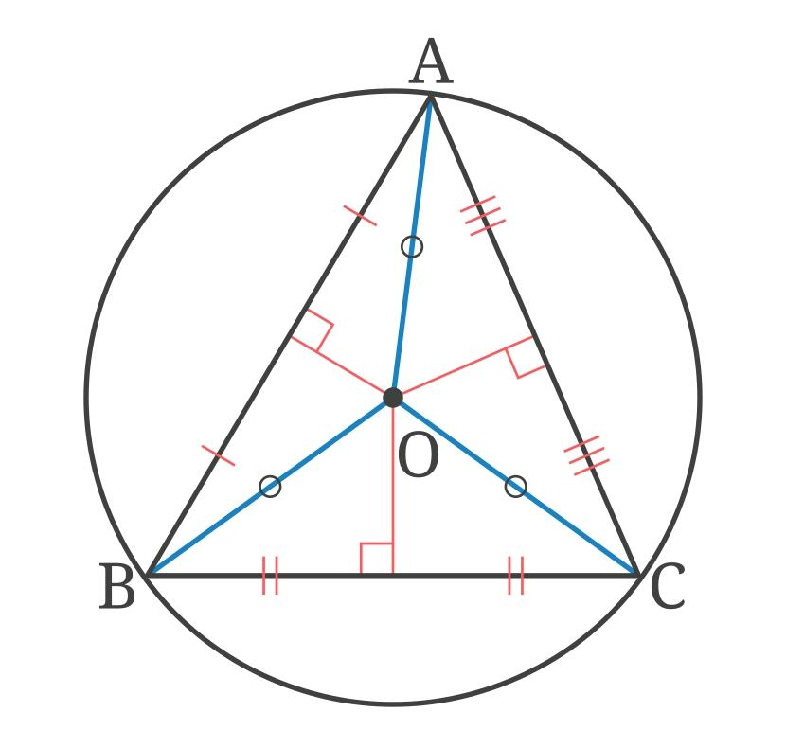
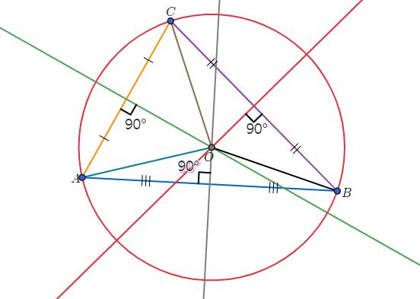

Angle Bisector Theorem
# Source: AI Source: Provided by: [Data Path: Persons Table -> ID Column: 1, Name_En Column: Motasem Essam] -> From: [ChatGPT] on [7/25/2026]
In a triangle, an angle bisector also creates a proportional relationship between the two parts of the opposite side.
If $AD$bisects $∠A$in $△ABC$, then:
$$\boxed{\frac{BD}{DC}=\frac{AB}{AC}}$$
This is called the Angle Bisector Theorem.

Example
# Source: AI Source: Provided by: [Data Path: Persons Table -> ID Column: 1, Name_En Column: Motasem Essam] -> From: [ChatGPT] on [7/25/2026]
Suppose:
$$AB=6, AC=9$$
and the angle bisector from $A$meets $BC$at $D$.
Then:
$$\frac{BD}{DC}=\frac{6}{9}$$
Simplifying:
$$\frac{BD}{DC}=\frac{2}{3}$$
So the opposite side is divided in the ratio:
$$\boxed{BD:DC=2:3}$$
Notice that an angle bisector does not generally divide the opposite side into equal lengths.

Important Distinction
# Source: AI Source: Provided by: [Data Path: Persons Table -> ID Column: 1, Name_En Column: Motasem Essam] -> From: [ChatGPT] on [7/25/2026]
There are two different meanings of "bisect":
Bisecting an Angle
$$∠ABD=∠DBC$$
The angles are equal.
Bisecting a Segment
$$AM=MB$$
The segments are equal.
Therefore:
Bisect means "divide into two equal parts," but the type of object being divided determines what is equal.

Properties
# Source: AI Source: Provided by: [Data Path: Persons Table -> ID Column: 1, Name_En Column: Motasem Essam] -> From: [ChatGPT] on [7/25/2026]
Angle Bisector
If $BD$bisects $∠ABC$:
$$\boxed{∠ABD=∠DBC}$$
Segment Bisector
If $M$bisects $\overset{‾}{AB}$:
$$\boxed{AM=MB}$$
Perpendicular Bisector
If $l$is the perpendicular bisector of $\overset{‾}{AB}$:
$$\boxed{AM=MB}$$
and:
$$\boxed{l⊥\overset{‾}{AB}}$$

Relationship with Related Concepts
# Source: AI Source: Provided by: [Data Path: Persons Table -> ID Column: 1, Name_En Column: Motasem Essam] -> From: [ChatGPT] on [7/25/2026]
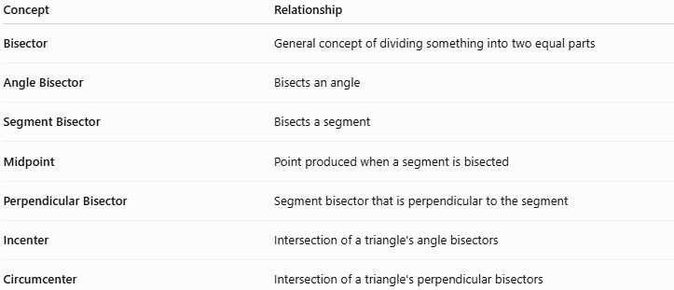
Concept | Relationship
Bisector | General concept of dividing something into two equal parts
Angle Bisector | Bisects an angle
Segment Bisector | Bisects a segment
Midpoint | Point produced when a segment is bisected
Perpendicular Bisector | Segment bisector that is perpendicular to the segment
Incenter | Intersection of a triangle's angle bisectors
Circumcenter | Intersection of a triangle's perpendicular bisectors

Key Points
# Source: AI Source: Provided by: [Data Path: Persons Table -> ID Column: 1, Name_En Column: Motasem Essam] -> From: [ChatGPT] on [7/25/2026]
- Bisect means divide into two equal parts.
- An angle bisector creates two equal angles.
- A segment bisector creates two equal segments.
- A midpoint is the point where a segment is bisected.
- A perpendicular bisector is both a segment bisector and perpendicular to the segment.
- Angle bisectors are related to the incenter.
- Perpendicular bisectors are related to the circumcenter.
- An angle bisector in a triangle does not necessarily divide the opposite side equally.

Conclusion
# Source: AI Source: Provided by: [Data Path: Persons Table -> ID Column: 1, Name_En Column: Motasem Essam] -> From: [ChatGPT] on [7/25/2026]
A bisector is a fundamental geometric concept describing something that divides another object into two congruent parts. Depending on what is being divided, it can be an angle bisector, segment bisector, or perpendicular bisector.

